**CSUEB – STAT 6305 – Winter 2017 - Prof Yan Zhou**

**Homework 7 - Henry Lankin**

March 2, 2017

**HW 7: 17.31, 17.32**

17.31

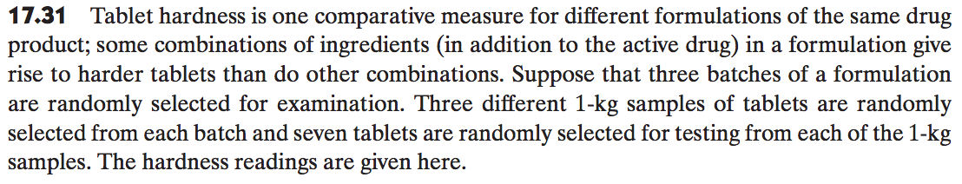

1. Identify the design.

This experiment uses a nested design where the major factor (batch) is a random effect with 3 treatment levels and the minor factor (sample) is a random effect with 9 total treatment levels, 3 for each level of the site factor. There are 7 replications within each level of the batch treatment.

1. Give an appropriate model with assumptions.

Nested factorial design model:

$$y_{ijk}=μ+τ_{i}+β_{j(i)}{+ε}_{ijk}$$

$$i=1, 2, 3; j=1, 2, 3,; k=1, 2,…,7$$

$y_{ij}k$– the hardness reading of the $k^{th}$ tablet in the $j^{th}$ sample from the $i^{th}$ batch representing the observed response variable: 63 observations from 7 replications of the 9 batch-sample nested treatment combinations.

$τ_{i}$– the random effect due to the $i^{th}$ batch: 3 treatment levels chosen from a continuous distribution of batches

$β_{j(i)}$– the random effect due to the $j^{th}$ sample in the $i^{th}$ batch: 3 treatment levels chosen from a continuous distribution of samples within each of the 3 batch levels

$ε_{ijk}$– random error associated with each batch-sample nested combination: 63 residual errors

Assumptions:

1. The random effect due to the $i^{th}$ batch, $τ_{i}$, is assumed to follow a normal distribution with mean $0$ and variance ${σ_{τ}}^{2}$.
2. The $τ_{i}$’s are independent of each other.
3. The random effect due to the $j^{th}$ sample in the $i^{th}$ batch, $β_{j(i)}$, is assumed to follow a normal distribution with mean $0$ and variance ${σ_{β(τ)}}^{2}$.
4. The $β_{j(i)}$’s are independent of each other.
5. The residual effect, $ε_{ijk}$, is assumed to follow a normal distribution with mean $0$ and common variance of ${σ_{ε}}^{2}$.
6. The $ε_{ijk}$’s are independent of each other.
7. Give the sources of variability and degrees of freedom for an $AOV$.

|  |  |  |  |  |  |  |  |
| --- | --- | --- | --- | --- | --- | --- | --- |
| **Source** | **DF** | **SS** | **Mean Square** | **EMS** | **Estimated variability** | **F Value** | **Pr > F** |
| **B: Batch** | $$2$$ | $$9095.523810$$ | $$4547.761905$$ | $${σ_{ε}}^{2}+7{σ_{β(τ)}}^{2}+{{21σ}_{τ}}^{2}$$ | $${σ_{τ}}^{2}=214.4293$$ | $$101.63$$ | $$<.0001$$ |
| **S(B): Sample(Batch)** | $$6$$ | $$268.476190$$ | $$44.746032$$ | $${σ_{ε}}^{2}+7{σ_{β(τ)}}^{2}$$ | $${σ_{β(τ)}}^{2}=2.222978$$ | $$1.53$$ | $$0.1851$$ |
| **Error** | $$54$$ | $$1576.000000$$ | $$29.185185$$ | $${σ_{ε}}^{2}$$ | $${σ_{ε}}^{2}=29.185185$$ |  |  |

1. Perform an analysis of variance and draw conclusions about the tablet hardness data for the formulation under study. Use $α=0.05$.

* Test for significance of the major factor, the batch the tablet is from, on tablet hardness:

Hypothesis:

$$H_{0}:{σ_{τ}}^{2}=0$$

$$H_{a}:{σ_{τ}}^{2}>0$$

Test statistic:

$$F=\frac{MSB}{MSS(B)}=\frac{SSB/(b-1)}{SSS/b(s-1)}=\frac{9095.52/2}{268.48/6}=101.63$$

Rejection region:

At $α=0.05$, we reject the null hypothesis for $F>F_{2,6}\left(0.05\right)=5.14$.

Conclusion:

Since $F=101.63>5.14$ and this test gives a $p$-vlaue $<0.0001$, we reject the null hypothesis and conclude that the batch factor significantly affects the mean hardness reading of the tablet.

* Test for significance of the minor factor, the sample the tablet is from, on tablet hardness:

Hypothesis:

$$H_{0}:{σ_{β(τ)}}^{2}=0$$

$$H_{a}:{σ_{β(τ)}}^{2}>0$$

Test statistic:

$$F=\frac{MSS(B)}{MSE}=\frac{SSS/b(s-1)}{SSE/bs(n-1)}=\frac{268.48/6}{1576.00/54}=1.53$$

Rejection region:

At $α=0.05$, we reject the null hypothesis for $F>F_{6,54}\left(0.05\right)=2.27$.

Conclusion:

Since $F=1.53<2.27$ and this test gives a $p$-vlaue $=0.1851$, we fail to reject the null hypothesis and conclude that the sample in each batch level does not significantly affect the mean hardness reading of the tablet.

17.32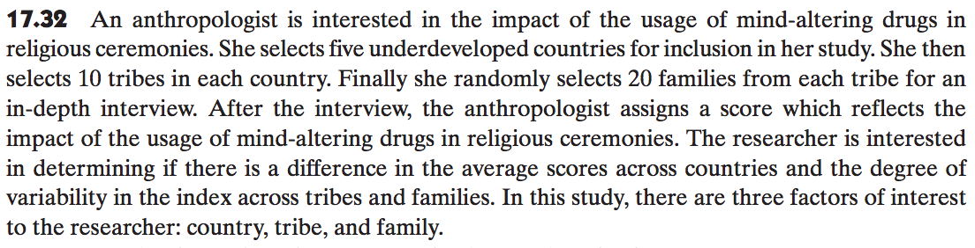

1. Identify each of the factors as fixed or random; justify your answer.

* Country is a random effect because there are many possible underdeveloped countries that could have been chosen.
* Tribe is a random effect because there are many possible tribes that could have been chosen in each country.
* Family is a random effect because 20 families are randomly chosen from each tribe.

1. State whether the factors are nested or crossed; provide reasons for your answers.

* Country is the major factor: $C$
* Tribe is a minor factor nested in the country factor: $T(C)$
* Family is a minor factor nested in the tribe factor: $F(T,C)$

1. Provide an AOV table that includes source of variation, degrees of freedom, and expected mean squares.

|  |  |  |  |  |
| --- | --- | --- | --- | --- |
| **Source** | **DF** | **SS** | **Mean Square** | **EMS** |
| **C: Country** | $$4$$ | $$SSC$$ | $$MSC$$ | $${σ_{ε}}^{2}+σ_{F(T,C)}^{2}+20σ_{T(C)}^{2}+200{σ_{C}}^{2}$$ |
| **T(C): Tribe(Country)** | $$45$$ | $$SST(C)$$ | $$MST(C)$$ | $${σ_{ε}}^{2}+σ_{F(T,C)}^{2}+20σ_{T(C)}^{2}$$ |
| **F(T, C): Family(Tribe, Country)** | $$950$$ | $$SSF(T,C)$$ | $$MSF(T,C)$$ | $${σ_{ε}}^{2}+σ_{F(T,C)}^{2}$$ |
| **Error** |  |  |  |  |

|  |  |  |  |  |
| --- | --- | --- | --- | --- |
| **Source** | **DF** | **SS** | **Mean Square** | **EMS** |
| **C: Country** | $$4$$ | $$SSC$$ | $$MSC$$ | $${σ_{ε}}^{2}+σ_{F(T,C)}^{2}+20σ_{T(C)}^{2}+200{σ_{C}}^{2}$$ |
| **T(C): Tribe(Country)** | $$45$$ | $$SST(C)$$ | $$MST(C)$$ | $${σ_{ε}}^{2}+σ_{F(T,C)}^{2}+20σ_{T(C)}^{2}$$ |
| **Error** | $$950$$ | $$SSE$$ | $$MSE$$ | $${σ_{ε}}^{2}$$ |

SAS code:

* input data with do loop;

**data** tablethardness_looped;

do batch = **1** to **3**;

do sample **1** to **3**;

do rep **1** to **7**;

input response@@;

output;

end;

end;

end;

cards;

'Response'

85

94

91

98

85

96

93

76

87

90

91

88

94

96

95

98

94

96

99

100

93

108

100

105

109

104

102

108

117

106

103

109

100

104

102

101

108

100

99

117

109

105

71

85

78

68

85

67

76

81

70

84

83

72

81

78

72

68

80

72

75

79

74

;

**run**;

**proc** **print** data=tablethardness_looped;

**run**;

* input data with stacked data;

**data** tablethardness;

input Sample$ Batch$ Response;

cards;

1 1 85

1 1 94

1 1 91

1 1 98

1 1 85

1 1 96

1 1 93

2 1 76

2 1 87

2 1 90

2 1 91

2 1 88

2 1 94

2 1 96

3 1 95

3 1 98

3 1 94

3 1 96

3 1 99

3 1 100

3 1 93

1 2 108

1 2 100

1 2 105

1 2 109

1 2 104

1 2 102

1 2 108

2 2 117

2 2 106

2 2 103

2 2 109

2 2 100

2 2 104

2 2 102

3 2 101

3 2 108

3 2 100

3 2 99

3 2 117

3 2 109

3 2 105

1 3 71

1 3 85

1 3 78

1 3 68

1 3 85

1 3 67

1 3 76

2 3 81

2 3 70

2 3 84

2 3 83

2 3 72

2 3 81

2 3 78

3 3 72

3 3 68

3 3 80

3 3 72

3 3 75

3 3 79

3 3 74

;

**run**;

**proc** **print** data=tablethardness;

**run**;

**proc** **glm** data=tablethardness;

class batch sample;

model response = batch sample(batch);

random batch sample(batch) / test;

**run**;

**quit**;